What is artificial intelligence?
Google cloud
Artificial intelligence is a discipiline. branch of computer science that deals with the creation of intelligent agent that can reason, learn, and act autonomously thus mimicking human intelligence
- Based on rules

ML is a subfield. the development and study of statistical algorithms that can learn from data and generalise to unseen data, and thus perform tasks without explicit instructions.[
- Supervised- we teach or train the machine using the labelled data(correct answers or classifications) which means each input has the correct output in the form of answer or category attached to it
- A regression is used to predict continuous values such as house prices, stock prices or temperature.
- A classification is used to predict categorical values such as whether a customer will buy or not, whether an email is spam or not or whether a medical image shows a tumor or not
- Introduction to R, Introduction to the Tidyverse (data wrangling/visualization), Data manipulation with dplyr, Joining data with dplyr, Intro to statistics in R, Intro to data visualization with ggplot2, Exploratory data analysis in R, Sampling in R, and Hypothesis testing in R

- Unsupervised- machine is given with data that has no labels or categories. It analyzes the data on its own to find patterns, groups or relationships without any prior knowledge.

- Clustering algorithms work by repeatedly moving data points closer to to the center of their group (cluster) and farther from points in other groups. This helps the algorithm to create clear and meaningful clusters.
- k-Means Clustering (for grouping similar data points together)
- Principal Component Analysis (PCA) (for reducing the number of features in the data)
- DBSCAN (for identifying clusters of varying shapes)
- Hierarchical Clustering (for creating a hierarchy of clusters)

Difference between Supervised and Unsupervised Learning

MIT
ML algorithm is mathematical sequence if steps with objective of learning rules from data
AI vs Machine Learning vs Deep Learning: Understanding the Differences

Generative ai produces content, including text images

Break down the subfields using MIT slides
Talk about data camp and MIT courses taken
Dive into
Predictive modeling as ml
Briefly outline your work and what you plan on doing with
Ensemble Learning - GeeksforGeeks
Ensemble learning is a method where we use many small models instead of just one. Each of these models may not be very strong on its own, but when we put their results together, we get a better and more accurate answer.

Types of Ensembles Learning in Machine Learning
There are three main types of ensemble methods:
- Bagging (Bootstrap Aggregating): Models are trained independently on different random subsets of the training data. Their results are then combined—usually by averaging (for regression) or voting (for classification). This helps reduce variance and prevents overfitting.
- Boosting: Models are trained one after another. Each new model focuses on fixing the errors made by the previous ones. The final prediction is a weighted combination of all models, which helps reduce bias and improve accuracy.
- Stacking (Stacked Generalization): Multiple different models (often of different types) are trained and their predictions are used as inputs to a final model, called a meta-model. The meta-model learns how to best combine the predictions of the base models, aiming for better performance than any individual model.
While stacking is also a method but bagging and boosting method is widely used and lets see more about them.
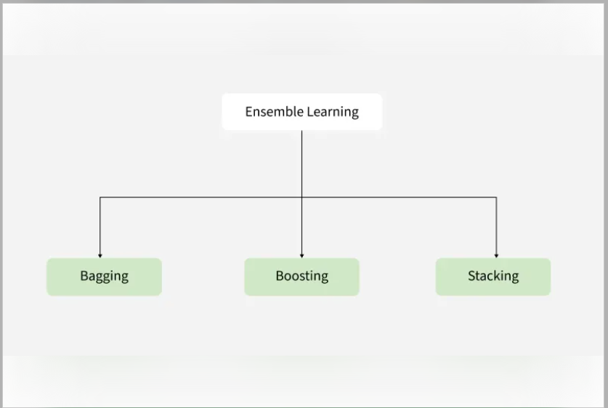
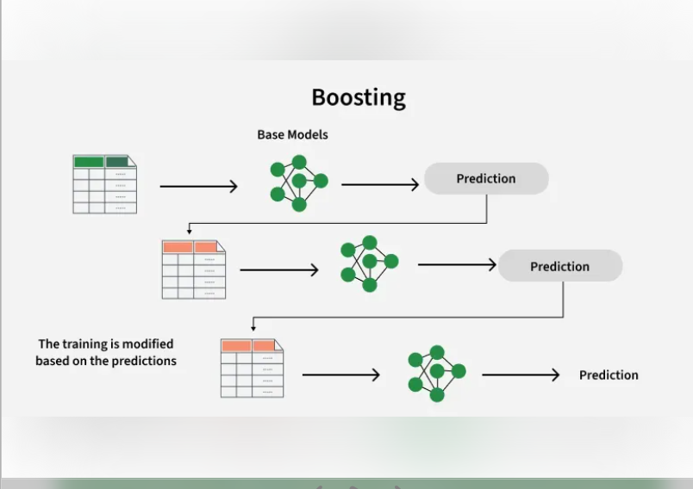

Then go into generative AI and LLMs
Briefly outline history of LLMs and how it has been used in healthcare
- Radiology nlp
- P[athology nlp
- Llm clinical summarization and evaluation
- Safety, deployment and evaluation frameworks

A compact guide to large language models
a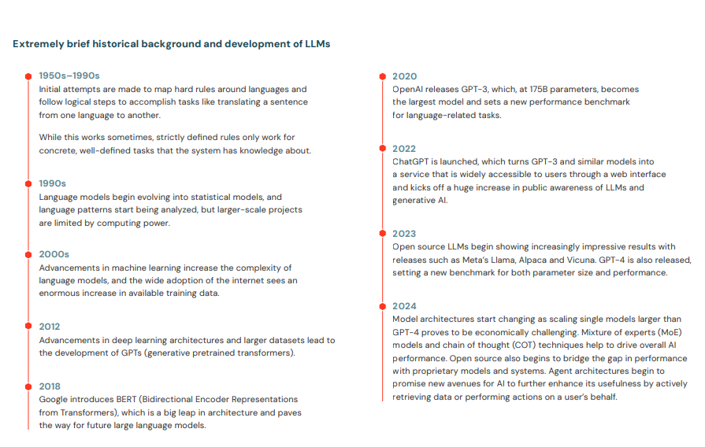

What attention means in a model (plain language)
In a neural network, attention means:
For each word, the model learns how much it should “look at” every other word when forming its understanding.
So instead of processing words in isolation or strictly in order, the model asks:
- When I see “carcinoma”, should I look at: left, breast, the, that. And it learns these patterns from the data, not rules.

3. Why attention was revolutionary
Before attention:
- Models (like RNNs) read text one word at a time
- Information faded as sequences got longer
- Long reports = poor memory
With attention:
- Any word can directly reference any other word
- Distance doesn’t matter
- Long documents (radiology reports, pathology reports) become tractable
This is why Transformers replaced RNNs.
NLP is the field that studies how to make computers understand language; LLMs are transformer-based models that use attention to do many NLP tasks at once, including summarization, by learning language patterns directly from data.

